**Jenkins Installation process for windows VM**

1. Open the default browser of windows VM
2. Download java <https://download.oracle.com/java/17/archive/jdk-17.0.8_windows-x64_bin.msi> in your windows VM
3. Go to the Jenkins website <https://www.jenkins.io/download/>
4. **Download Jenkins 2.401.3 LTS for windows (msi file)**
5. Open downloaded file and follow the procedure:
   * Select Run service as localsystem
   * Give your port number (8081)
   * Select the java 17 path
   * Click on next and start the installation procedure
   * Click on finish
6. Now you have installed Jenkins in your windows VM now u have to run and access Jenkins server
   * Go to Jenkins folder using command prompt (C:\Program Files\Jenkins>)
   * Run this command to start Jenkins server **java -jar Jenkins.war**

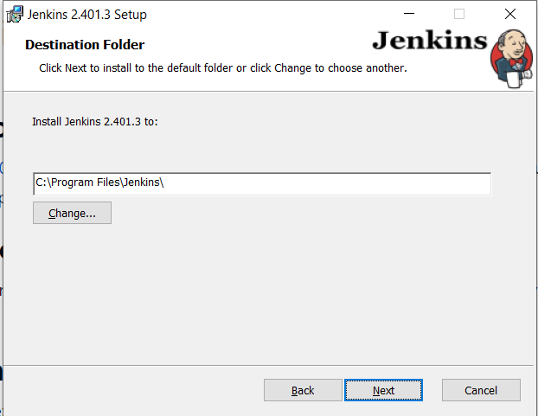

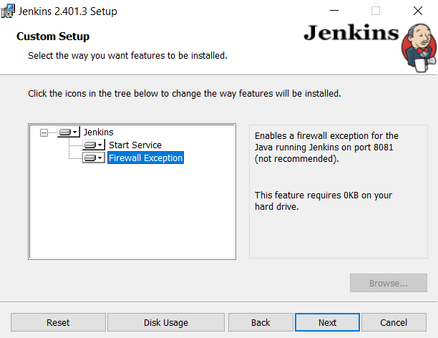

**In Linux VM**

1. Setup a linux VM and access it through ssh
2. RUN sudo apt update && sudo apt upgrade
3. RUN sudo apt install curl -y && curl -fsSL https://pkg.jenkins.io/debian/jenkins.io-2023.key | sudo tee \

/usr/share/keyrings/jenkins-keyring.asc > /dev/null

1. RUN echo deb [signed-by=/usr/share/keyrings/jenkins-keyring.asc] \

https://pkg.jenkins.io/debian binary/ | sudo tee \

/etc/apt/sources.list.d/jenkins.list > /dev/null

1. sudo apt update && sudo apt install openjdk-17-jdk -y && sudo apt install jenkins -y
2. command to run Jenkins **service Jenkins start**

**Configuring node slave**

* In the Jenkins web interface, go to "Manage Jenkins" > "Manage Nodes and Clouds."
* Click on "New Node" to create a new node configuration.
* Provide a name for the node (e.g., "MySlaveNode").
* Choose the "Permanent Agent" option and click on "OK."
* On the next page, you'll see the "Launch method" options. Choose "Launch agent via Java Web Start."
* Click on "Generate" to generate the agent command.
* Copy the generated command.

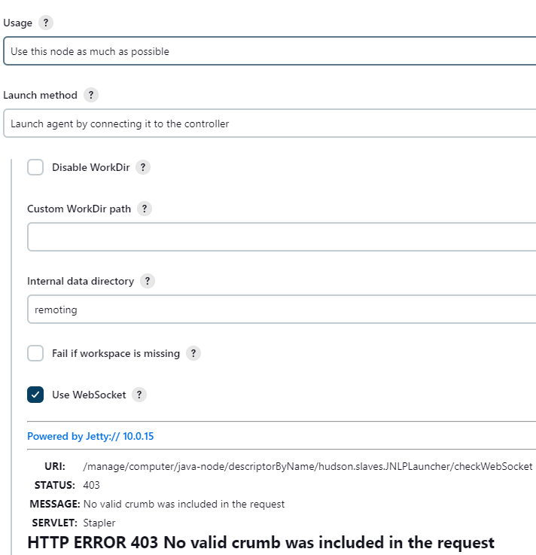

After setting up Jenkins slave node

* In the initial state the slave node will not be running
* Click on the slave node
* Download slave agent (ex: sudo wget http://20.98.219.152:8080/jnlpJars/agent.jar)
* Move agent.jar to your give path (ex: sudo mv agent.jar /opt)
* And run the command(ex: sudo java -jar agent.jar -jnlpUrl http://20.98.219.152:8080/computer/java%2Dnode/jenkins-agent.jnlp -secret f303076db33dc4672ffad3470e681ec35c6bffaaebb52c1a1d837672c3b430de -workDir "/opt/build")

**Build pipeline for java project**

Note : Before starting with steps you need to install maven

* Install plugins
  + [Maven Integration pluginVersion3.22](https://plugins.jenkins.io/maven-plugin)
* Configure java and maven path in Jenkins
* Manage Jenkins > tools > add jdk path and maven path
* A screenshot of a computer

  Description automatically generated

* Choose pipeline project

* Give a description to the project
* Create a folder inside Jenkins work space(C:\\Program Files\\Jenkins\\workspace\\project\\sample-java\\maven-jenkins\\my-app)
* Import project manually once in that folder
* Apply below Jenkins script

pipeline {

agent any

tools {

maven "maven_home"

jdk "java_home"

}

stages {

stage('Git pull latest code') {

steps {

// Checkout the source code from the Git repository

bat 'cd C:\\Program Files\\Jenkins\\workspace\\project\\sample-java\\maven-jenkins\\my-app'

bat 'git pull origin master'

}

}

stage('Build') {

steps {

// Change the directory to the specific project folder

dir("C:\\Program Files\\Jenkins\\workspace\\project\\sample-java\\maven-jenkins\\my-app") {

// Ensure that you are in the correct directory containing the pom.xml file

bat 'dir' // Add this line for debugging, it will list the files in the current directory

bat 'mvn -B -DskipTests clean package'

}

}

}

}

}

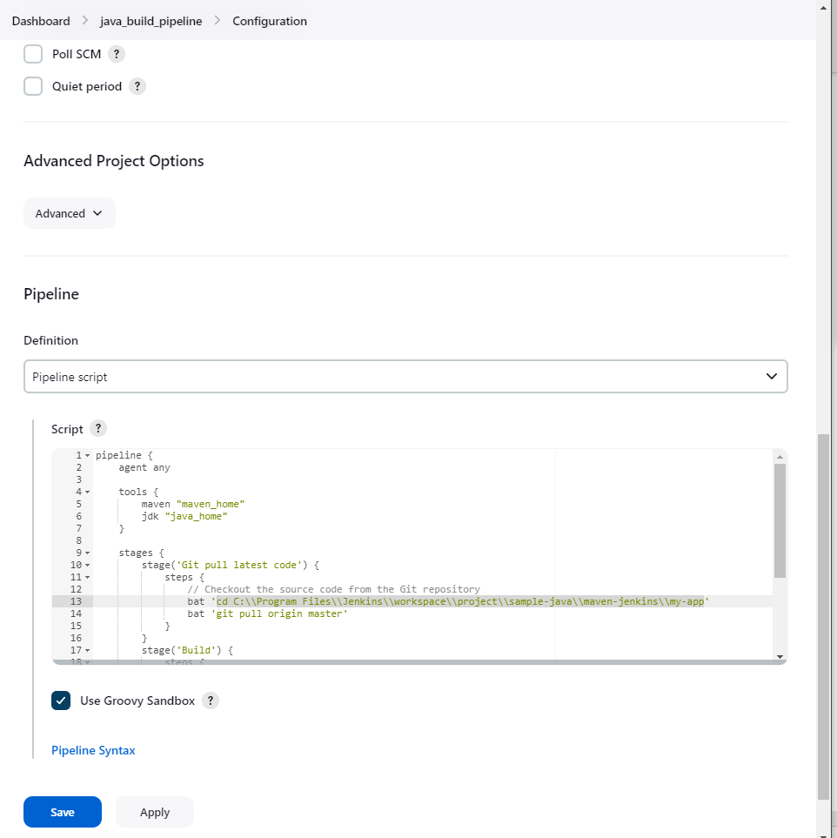

* In the first stage git command pull the latest code
* In the second stage actual build will happen inside Jenkins workspace